- 顺序表
package jing.able.dao;
import jing.able.impl.ISequence;
import java.util.Arrays;
public class Sequence implements ISequence {
private Object[] elemData;
private int usedSize;
public static final int DEFAULT_CAPACITY= 10;
public void SequenceImpl(){
this.elemData = new Object[DEFAULT_CAPACITY];
this.usedSize = 0;
}
private boolean isFull(){
return this.usedSize == this.elemData.length;
}
@Override
public boolean add(int pos, Object data) {
//1.判断POS的合法性，放入数据后是否会发生溢出
if (pos < 0 || pos > this.usedSize) {
return false;
}
if (isFull()) {
//扩容
this.elemData = Arrays.copyOf(this.elemData, this.elemData.length * 2);
}
//2.挪数据
int i = usedSize;
for (i = usedSize; i >= pos; i--) {
this.elemData[i + 1] = this.elemData[i];
}
//3.放入数据
this.elemData[pos] = data;
this.usedSize++;
return true;
}
private boolean isEmpty(){
return this.usedSize == 0;
}
@Override
public int search(Object key) {
if(key==null){
throw new UnsupportedOperationException("不可以传null作为参数");
}
if(isEmpty()){
return -1;
}
for(int i = 0;i<=this.usedSize;i++){
if(this.elemData[i].equals(key)){ //equals比较数值大小
return i;
}
}
return -1;
}
@Override
public boolean contains(Object key) {
if(key==null){
throw new UnsupportedOperationException("不可以传null作为参数");
}
if(isEmpty()){
return false;
}
for(int i = 0;i<=this.usedSize;i++){
if(this.elemData[i].equals(key)){ //equals比较数值大小
return true;
}
}
return false;
}
@Override
public Object getPos(int pos) {
if(pos<0||pos>=this.usedSize){
return null;
}
return this.elemData[pos];
}
@Override
public Object remove(Object key) {
int index = search(key);
if(index==-1){
return null;
}
Object oldData=this.elemData[index];
int i =0;
for (i = index; i < this.usedSize-1; i++) {
this.elemData[i] = this.elemData[i+1];
}
this.elemData[i+1] = null;
this.usedSize--;
return oldData;
}
@Override
public int size() {
return this.usedSize;
}
@Override
public void display() {
for (int i = 0; i <this.usedSize ; i++) {
System.out.println(this.elemData[i]);
}
}
@Override
public void clear() {
for (int i = 0; i <this.usedSize ; i++) {
this.elemData[i] = null;
}
this.usedSize=0;
}
}

- 不带头结点的单向非循环链表
package jing.able.dao;
import jing.able.impl.ILinked;
public class Linked implements ILinked {
class Node {
private Node next;
private int data;
public Node(int data){
this.data= data;
this.next = null;
}
}
private Node head;
public Linked(){
this.head = null;
}
@Override
//头插法
public void addFirst(int data) {
Node node = new Node(data);
if (head==null){
this.head = node;
}else{
node.next = this.head;
this.head = node;
}
}
@Override
//尾插法
public void addLast(int data) {
Node node = new Node(data);
Node cur = this.head;
if (cur==null){
this.head = node;
}else {
while (cur.next != null) {
cur = cur.next;
}
cur.next = node;
node.next = null;
}
}
private void cheackIndex(int index ){
if (index < 0 || index > getLength()){
throw new UnsupportedOperationException("插入不合法");
}
}
@Override
//任意位置插入,第一个数据节点为0号下标
public boolean addindex(int index, int data) {
cheackIndex(index);
Node cur = this.head;
Node node = new Node(data);
for (int i = 0;i < index; i++){
cur = cur.next;
}
node.next = cur.next;
cur.next = node;
return true;
}
@Override
public boolean contains(int key) {
Node cur = this.head;
while(cur.next!=null){
if(cur.data==key){
return true;
}
cur = cur.next;
}
return false;
}
private Node searchPre(int key){
//1.判断是否为第一个节点
Node cur = this.head;
if (cur.data==key){
return this.head;
}else{ //2.if(cur.next.data !=key)
while(cur.next !=null){
if(cur.next.data == key){
return cur;
}
cur = cur.next;
}
return null;

}
}
@Override
//删除
public int remove(int key) {
Node cur =searchPre(key);
int oldData=0;
if (cur.next ==null){
throw new UnsupportedOperationException("没有节点");
}
if (cur==this.head&&cur.data==key){
oldData = this.head.data;
this.head=this.head.next;
return oldData;
}
Node delNode = cur.next;
cur.next = delNode.next;

return 0;
}
@Override
//删除所有值为key的节点
public void removeAllKey(int key) {
Node pre = this.head;
Node cur = this.head.next;
while(cur != null){
if (cur.data == key){
pre.next = cur.next;
cur = cur.next;
}else{
pre = cur;
cur = cur.next;
}
}
if (this.head.data==key){
this.head=this.head.next;
}
}
@Override
public int getLength() {
int count = 0;
Node cur = this.head;
while(cur.next != null){
count++;
cur = cur.next;
}
return count;
}
@Override
public void display() {
Node cur = this.head;
while(cur.next != null){
System.out.println(cur.data+" ");
cur = cur.next;
}
}
@Override
//清除
public void clear() {
while(this.head !=null){
Node cur = this.head.next;
this.head = null;
head = cur;
}
}
}

- 带头结点的循环单链表
package jing.able.dao;
import jing.able.impl.CLinkList;
public class CHeadLinkList implements CLinkList {
class Node {
private Node next;
private int data;
public Node(){
//标志头节点
this.data = -1;
}
public Node(int data){
this.data= data;
}
}
private Node head;

public CHeadLinkList(){
this.head = new Node();
this.head.next = this.head;
}
@Override
public void addFirst(int data) {
Node node = new Node(data);
node.next = this.head.next;
this.head.next = node;
}
@Override
public void addLast(int data) {
Node node =new Node(data);
Node cur = this.head;
while(cur.next != this.head){
cur = cur.next;
}
node.next = this.head;
cur.next = node;
}
private void cheackIndex(int index ){
if (index < 0 || index > getLength()){
throw new UnsupportedOperationException("插入不合法");
}
}
@Override
public boolean addindex(int index, int data) {
cheackIndex(index);
Node node =new Node(data);
Node cur = this.head;
for(int i = 1; i<index;i++){
cur = cur.next;
}
node.next = cur.next;
cur.next = node;
return true;
}
@Override
public boolean contains(int key) {
Node cur = this.head.next;
while(cur != this.head ){
if(cur.data== key){
return true;
}
cur = cur.next;
}
return false;
}
private Node searchPre(int key){
Node pre = this.head;
while(pre.next != this.head){
if (pre.next.data == key){
return pre;
}
pre = pre.next;
}
return null;
}
@Override
public int remove(int key) {
Node pre = searchPre(key);
if (pre == null) {
throw new UnsupportedOperationException("key不是一个节点");
}
int oldData = 0;
Node delNode = pre.next;
oldData = delNode.data;
pre.next = delNode.next;
return oldData;
}
@Override
public void removeAllKey(int key) {
Node cur = this.head.next;
Node pre = this.head;
while(cur != this.head){
if(cur.data == key){
pre.next = cur.next;
cur = cur.next;
}else{
pre = cur;
cur = cur.next;
}
}
}
@Override
public int getLength() {
Node cur = this.head.next;
int count = 0;
while(cur !=this.head){
count++;
cur = cur.next;
}
return count;
}
@Override
public void display() {
Node cur = this.head.next;
while(cur !=this.head){
System.out.println(cur.data + " ");
cur = cur.next;
}
System.out.println();
}
@Override
public void clear() {

while(this.head.next !=this.head){
Node cur = this.head.next;
this.head.next = cur.next;
cur.next = null;
}
this.head.next = null;
}
}

- 不带头结点的双向链表
package jing.able.dao;
import jing.able.impl.IDoubleLinked;
public class DoubleLinkList implements IDoubleLinked {
class Node {
private int data; //数据
private Node prev;//前驱
private Node next;//后驱
public Node(int data) {
this.data = data;
this.next = null;
this.prev = null;
}
}
private Node head;
private Node last; //last记录着链表的结尾
public DoubleLinkList() {
this.head = null;
this.last = null;
}
@Override
public void addFirst(int data) {
Node node = new Node(data);
if (head == null) { //第一次插入
this.head = node;
this.last = node;
} else {
node.next = this.head;
node.next.prev = node;
this.head = node;
}
}
@Override
public void addLast(int data) {
Node node = new Node(data);
if (head == null) { //第一次插入
this.head = node;
this.last = node;
} else {
this.last.next = node;
node.prev = this.last;
this.last = node;
}
}

private Node seachIndex(int index) {
cheackIndex(index);
Node cur = this.head;
int count = 0;
while (count < index) {
cur = cur.next;
count++;
}
return cur;
}
private void cheackIndex(int index) {
if (index < 0 || index > getLength()) {
throw new UnsupportedOperationException("插入不合法");
}
}
@Override
public boolean addindex(int index, int data) {
if (index == 0) {
addFirst(data);
return true;
}
if (index == getLength()) {
addLast(data);
return true;
}
Node node = new Node(data);
Node cur = seachIndex(index);
node.next = cur;
cur.prev.next = node;
node.prev = cur.prev;
cur.prev = node;
return true;
}
@Override
public boolean contains(int key) {
Node cur = this.head;
while (cur != null) {
if (cur.data == key) {
return true;
}
cur = cur.next;
}
return false;
}
@Override
public int remove(int key) {
Node cur = this.head;
while (cur != null) {
if (cur.data == key) {
int oldData = cur.data;
//删除的是头节点
if (cur == this.head) {
this.head = this.head.next;
this.head.prev = null;
} else {
//删除普通节点
cur.prev.next = cur.next;
if (cur.next != null) {
cur.next.prev = cur.prev;
} else {
//删除最后一个节点，last需要指回来
this.last = cur.prev;
}
}
return oldData;
}
cur = cur.next;
}
return -1;
}
@Override
public void removeAllKey(int key) {
Node cur = this.head;
while (cur != null) {
if (cur.data == key) {
//删除的是头节点
if (cur == this.head) {
this.head = this.head.next;
this.head.prev = null;
} else {
//删除普通节点
cur.prev.next = cur.next;
if (cur.next != null) {
cur.next.prev = cur.prev;
} else {
//删除最后一个节点，last需要指回来
this.last = cur.prev;
}
}
}
cur = cur.next;
}
}
@Override
public int getLength() {
int count = 0;
Node cur = this.head;
while (cur != null) {
count++;
cur = cur.next;
}
return 0;
}
@Override
public void display() {
Node cur = this.head;
while (cur != null) {
System.out.println(cur.data + " ");
cur = cur.next;
}
}
@Override
public void clear() {
while (this.head != null) {
Node cur = this.head.next;
this.head.next = null;
head.prev = null;
head = cur;
this.last = null;
}
}
public Node middleNode(Node head) {
Node cur = this.head;
int len = getLength() / 2;
for (int i = 0; i < len; i++) {
cur = cur.next;
}
return cur;
}
public class Solution {
public Node FindKthToTail(Node head, int k) {
Node cur = head;
Node fast = head;
Node slow = head;
int len = 0;
while (cur != null) {
len++;
cur = cur.next;
}
if (fast == null || k <= 0 || k > len) {
return null;
}
for (int i = 0; i < k; i++) {
fast = fast.next;
}
while (fast.next != null) {
fast = fast.next;
slow = slow.next;
}
return slow;
}
}
public Node mergeTwoLists(int x) {
Node beforStart = null;
Node beforEnd = null;
Node afterStart = null;
Node afterEnd = null;
Node pHead = this.head;
while (pHead != null) {
Node pHeadNext = pHead.next;
pHead.next = null;
if (pHead.data < x) {
if (beforStart == null) {
beforStart = pHead;
beforEnd = beforStart;
} else {
beforEnd.next = pHead;
beforEnd = beforEnd.next;
}
} else {
if (pHead.data > x) {
if (afterStart == null) {
afterStart = pHead;
afterEnd = afterStart;
} else {
afterEnd.next = pHead;
afterEnd = afterEnd.next;
}
}
pHead = pHeadNext;
}
if (beforStart == null ){
return afterStart;
}
beforEnd.next = afterStart;
return beforStart;
}
return beforStart;
}
}

- 简单栈的实现 ：先进后出
package jing.able.dao;
import jing.able.impl.IMyStack;
public class MyStack implements IMyStack {
private int[] elem;
private int top; //保存得是当前可以存放数据源数的下标
private int usedSize;
//默认栈的容量
private static final int DEFAULT_SIZE=10; //栈的长度
public MyStack(){
this.elem = new int[DEFAULT_SIZE];
this.top = 0;
this.usedSize = 0;
}
public boolean isFull(){
return this.top== this.elem.length;
}
@Override
public void push(int item) {
if(isFull()) {
throw new UnsupportedOperationException("栈为满");
}
this.elem[this.top++] =item;
}
@Override
public int pop() {
if (empty()){
throw new UnsupportedOperationException("栈为空");
}
int data = this.elem[this.top-1];
this.usedSize--;
this.top--;
return data;
}
@Override
public int peek() {
if (empty()){
throw new UnsupportedOperationException("栈为空");
}
return this.elem[this.top-1];
}
@Override
public boolean empty() {
if (this.top == 0) {
return true;
}
return false;
}
@Override
public int size() {
return this.usedSize;
}
}

- 队列的实现： 先进先出

package jing.able.dao;
import jing.able.impl.IMyQueue;
public class MyQueue implements IMyQueue {
class Node{
private Node next;
private int data;
public Node(int data){
this.data = data;
this.next = null;
}
}
private Node front ;//代表队列的头
private Node rear ;// 代表队列的尾
private int usedSize;
public MyQueue(){
this.rear = null;
this.front = null;
this.usedSize = 0;
}
// 判断这个队列是否为空
@Override
public boolean empty() {
return this.usedSize==0;
}
// 返回队首元素，但不出队列
@Override
public int peek() {
if (empty()){
throw new UnsupportedOperationException("队列为空");
}
return this.front.data;
}
// 返回队首元素，并且出队列
@Override
public int poll() {
if(empty()){
throw new UnsupportedOperationException("队列为空");
}
int data = this.front.data;
this.front=this.front.next;
this.usedSize--;
return data;
}
// 将 item 放入队列中
@Override
public void add(int item) {
Node node = new Node(item);
if(empty()){
this.front = node;
this.rear = node;
}else{
this.rear.next = node; //尾插
this.rear = this.rear.next;
}
this.usedSize++;
}
// 返回元素个数
@Override
public int size() {
return this.usedSize;
}
}

- 直接插入排序
1）时间复杂度 n*n
2）如果给定的是有序的数据，那么时间复杂度为O(n)
3）稳定性： 稳定
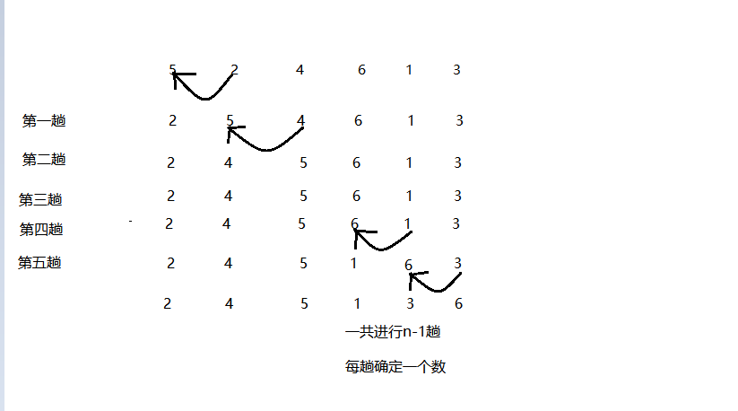
public class Demol {
public static void intsertSort(int[] array) {
int tmp = 0;
int i = 1;
int j = i-1;
for (i = 1; i < array.length; i++) {
tmp = array[i];
for ( j = i-1; j >= 0; j--) {
if (array[j] > tmp) {
array[j + 1] = array[j];
}else{
break;
}
}
array[j+1] = tmp;
}
}
}

- 希尔排序
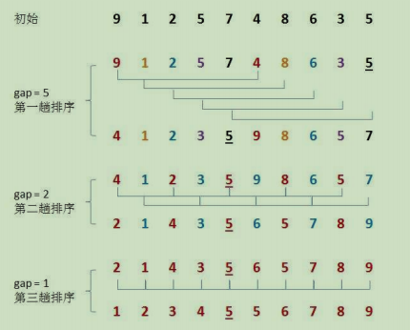
public class ShellDemol {
public static void shell (int[] array,int gap) {
int tmp = 0;
int i = gap;
int j = i - gap;
for (i = gap; i < array.length; i++) {
tmp = array[i];
for (j = i - gap; j >= 0; j = j - gap) {
if (array[j] > tmp) {
array[j + gap] = array[j];
} else {
break;
}
}
array[j + gap] = tmp;
}
}
public static void shellSort(int[] array){
int[] drr = {5,3,1};
for (int i = 0; i < drr.length ; i++) {
shell(array,drr[i]);
}
}
}
- 选择排序
1)时间复杂度：O(N^2)
2) 空间复杂度：O(1)
3) 稳定性：不稳定
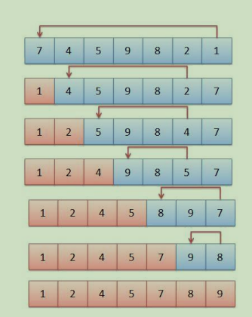
package jing.able;
public class SelectSort {
public static void selectSort(int[] array){
for (int i = 0; i <array.length ; i++) {
for (int j = 1; j < array.length; j++) {
if (array[j] < array[i]){
int temp = array[j];
array[j] = array[i];
array[i] = temp;
}
}
}
}
}
- 堆排序
1）时间复杂度：O(N*logN)
2）空间复杂度：O(1)
3) 稳定性：不稳定
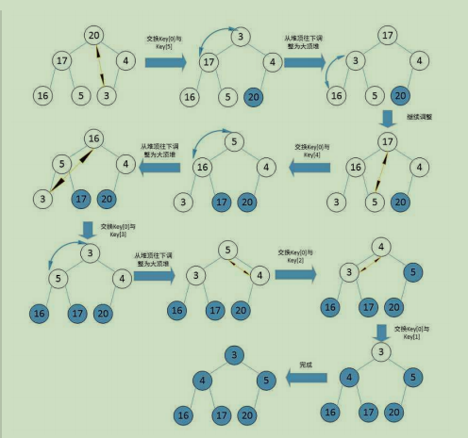
public class HeapSort {
public static void main(String[] args) {
int[] array = { 9, 8, 7, 6, 5, 4, 3, 2, 1, 0, -1, -2, -3 };
System.out.println("Before heap:");
ArrayUtils.printArray(array);
heapSort(array);
System.out.println("After heap sort:");
ArrayUtils.printArray(array);
}
public static void heapSort(int[] array) {
if (array == null || array.length <= 1) {
return;
}
buildMaxHeap(array);
for (int i = array.length - 1; i >= 1; i--) {
ArrayUtils.exchangeElements(array, 0, i);

maxHeap(array, i, 0);
}
}
private static void buildMaxHeap(int[] array) {
if (array == null || array.length <= 1) {
return;
}
int half = array.length / 2;
for (int i = half; i >= 0; i--) {
maxHeap(array, array.length, i);
}
}
private static void maxHeap(int[] array, int heapSize, int index) {
int left = index * 2 + 1;
int right = index * 2 + 2;
int largest = index;
if (left < heapSize && array[left] > array[index]) {
largest = left;
}
if (right < heapSize && array[right] > array[largest]) {
largest = right;
}
if (index != largest) {
ArrayUtils.exchangeElements(array, index, largest);
maxHeap(array, heapSize, largest);
}
}
}

- 冒泡排序
1）时间复杂度：O(N^2)
2）空间复杂度：O(1)
3）稳定性：稳定
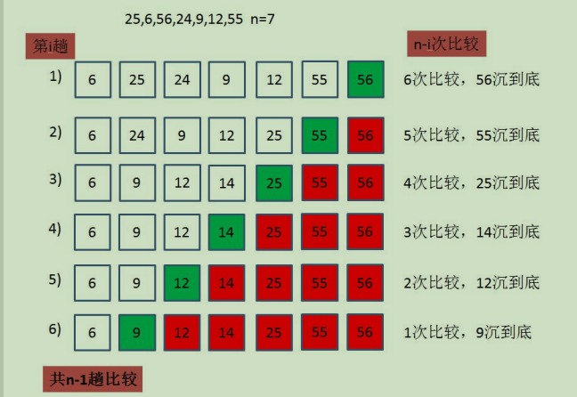
public class BubbleSort {
public static void main(String[] args) {
int[] array = { 9, 8, 7, 6, 5, 4, 3, 2, 1, 0, -1, -2, -3 };
System.out.println("Before sort:");
ArrayUtils.printArray(array);
bubbleSort(array);
System.out.println("After sort:");
ArrayUtils.printArray(array);
}
public static void bubbleSort(int[] array) {
if (array.length <= 1) {
return;
}
int size = array.length;
for (int i = size - 1; i > 0; i--) {
for (int j = 0; j < i; j++) {
if (array[j] > array[j + 1]) {
ArrayUtils.exchangeElements(array, j, j + 1);
}
}
}
}
}

- 快速排序
- 时间复杂度：nlogn
2）空间复杂度：O(logN)
3） 稳定性：不稳定
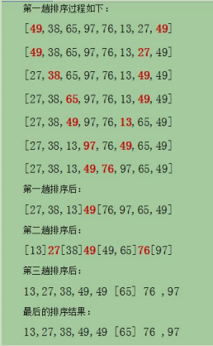
package jing.able.dao;
public class Qsort {
public static int partionSort(int[] array,int low,int high){
int tmp = array[low];
while(low < high){
while(low<high && array[high] >= tmp){
high--;
}
if(low == high){
break;
}else{
array[low] = array[high];
}
while(low<= high && array[low] <=tmp){
low++;
}
if (low == high){
break;
}else{
array[high] = array[low];
}
}
array[low] = tmp;
return low;
}
public static void quick(int[]array ,int low,int high){
if(low == high){
return;
}
takeThreeNumber(array,low,high);
int par = partionSort(array,low,high);
//递归保证左边有两个数以上
if (par>low+1){
quick(array,low,par-1);
}
//递归右边
if (par < high - 1){
quick(array,par+1,high);
}
}
public static void quickSort(int[] array){
quick(array,0,array.length-1);
}
public static void takeThreeNumber(int[] array,int low,int high){
int mid = (low+high)/2;
if(array[mid] > array[low] ){
swap(array,mid,low);
}
if (array[mid] > array[high] ){
swap(array,mid,high);
}
if (array[low] >array[high]){
swap(array,low,high);
}
}
private static void swap(int[] array,int low, int high) {
int tmp = array[high];
array[high] = array[low];
array[low] = tmp;
}
}
- 归并排序
1）时间复杂度：O(N*logN)
2） 空间复杂度：O(N)
3） 稳定性：稳定
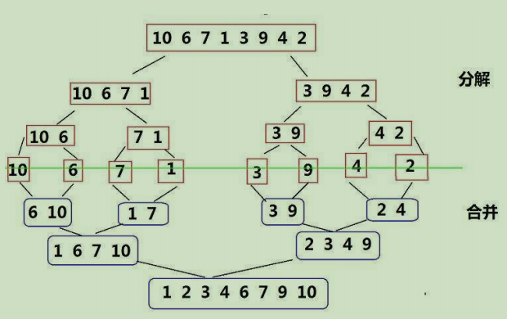
public class MergeSort {
public static void main(String[] args) {
int[] array = { 9, 8, 7, 6, 5, 4, 3, 2, 1, 0, -1, -2, -3 };
System.out.println("Before sort:");
ArrayUtils.printArray(array);
mergeSort(array);
System.out.println("After sort:");
ArrayUtils.printArray(array);
}
public static void mergeSort(int[] array) {
sortArray(array, 0, array.length - 1);
}
private static void sortArray(int[] array, int start, int end) {
// 单个元素不需要排序,直接返回
if (start == end) {
return;
}
int sortSize = end - start + 1;
int seperate;
if (sortSize % 2 == 0) {
seperate = start + sortSize / 2 - 1;
} else {
seperate = start + sortSize / 2;
}
sortArray(array, start, seperate);
sortArray(array, seperate + 1, end);
mergeArray(array, start, seperate, end);
}
private static void mergeArray(int[] array, int start, int seperate, int end) {
int totalSize = end - start + 1;
int size1 = seperate - start + 1;
int size2 = end - seperate;
int[] array1 = new int[size1];
int[] array2 = new int[size2];
for (int i = 0; i < size1; i++) {
array1[i] = array[start + i];
}
for (int i = 0; i < size2; i++) {
array2[i] = array[seperate + 1 + i];
}
int mergeCount = 0;
int index1 = 0;
int index2 = 0;
while (mergeCount < totalSize) {
// 先检查有没有其中的一个数组已经处理完
if (index1 == size1) {
for (int i = index2; i < size2; i++) {
array[start + mergeCount] = array2[i];
mergeCount++;
index2++;
}
} else if (index2 == size2) {
for (int i = index1; i < size1; i++) {
array[start + mergeCount] = array1[i];
mergeCount++;
index1++;
}
} else {
int value1 = array1[index1];
int value2 = array2[index2];
if (value1 == value2) {
array[start + mergeCount] = value1;
array[start + mergeCount + 1] = value1;
mergeCount += 2;
index1++;
index2++;
} else if (value1 < value2) {
array[start + mergeCount] = value1;
mergeCount++;
index1++;
} else if (value1 > value2) {
array[start + mergeCount] = value2;
mergeCount++;
index2++;
}
}
}
}
}

